Homework #5

Packet Sniffing and Spoofing

* Task 1:
  + Task 1a:  
    Here is a screenshot of me compiling and running the provided *sniffex.c* program.  
    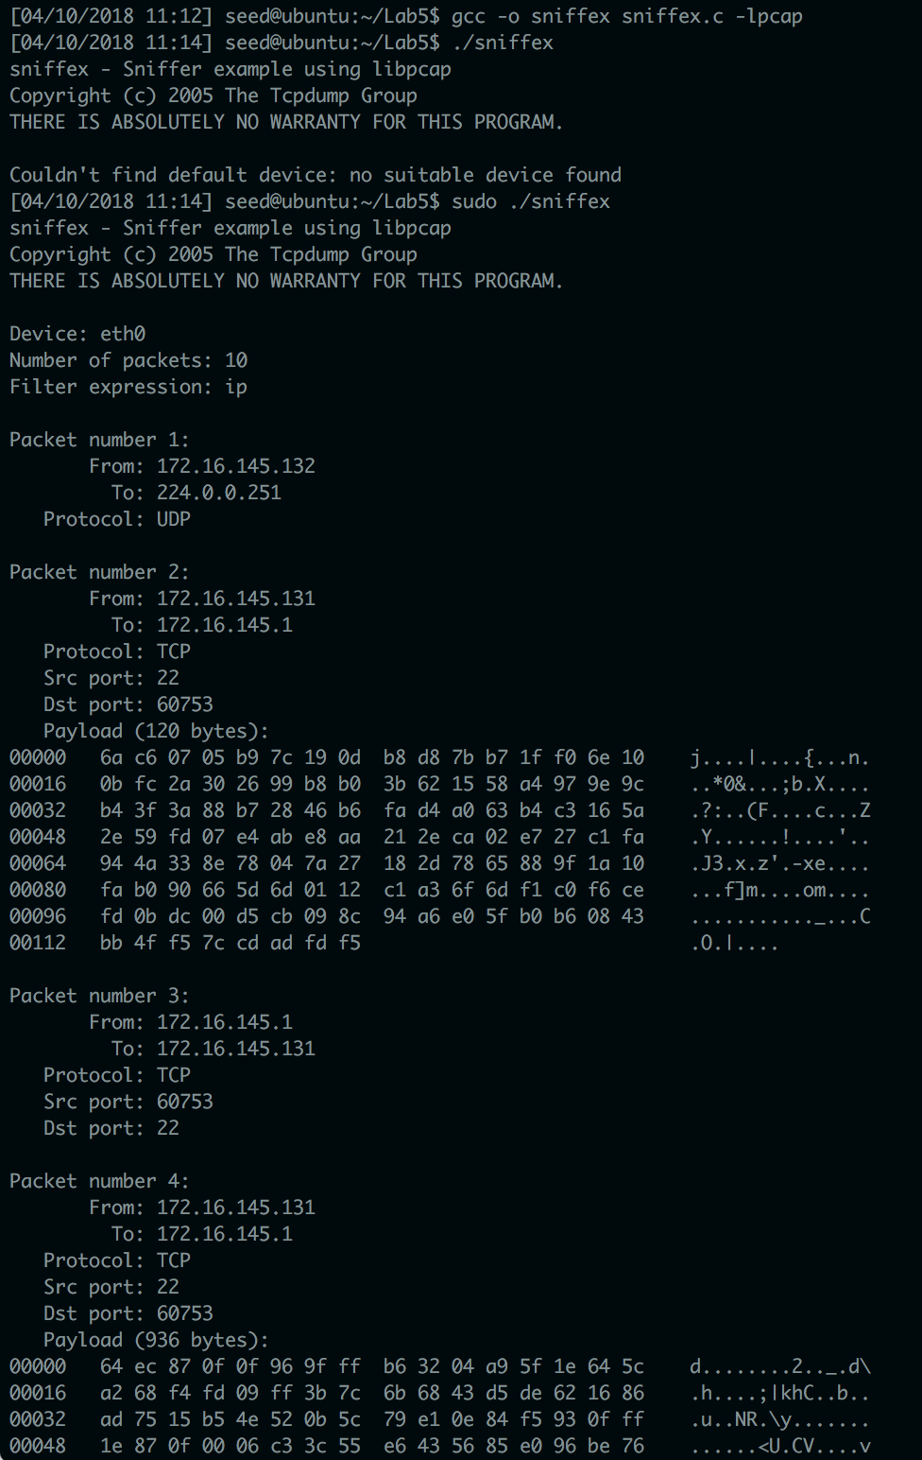  
    Note how root privilege was required to run *sniffex*.
    - Problem 1:  
      The sniffer must execute the following sequence of library calls: 1) set up the device being sniffed, 2) initialize sniffing, 3) filter traffic, 4) execute sniffing, 5) end sniffing session. The actual library calls being used by the *sniffex.c* program for each step in the sequence are: 1) *pcap_lookupdev*, which finds a device to sniff, and *pcap_lookupnet*, which finds the network number and mask for the device, 2) *pcap_open_live*, which initializes sniffing on the device, and *pcap_datalink*, which identifies the kind of device that is being sniffed, 3) *pcap_compile* and *pcap_setfilter*, which compiles and sets the filter being used for traffic, 4) *pcap_loop* or *pcap_next*, either of which sniff packets iteratively, 5) *pcap_freecode*, which frees up the allocated memory used by *pcap_compile* and *pcap_close*, which closes the sniffing session.
    - Problem 2:  
      Root privileges are required to run *sniffex* because *sniffex* needs to access a network device in order to be able to sniff it; only root users can access network devices, however. If *sniffex* is run *without* root privileges, it will fail at the following block of code, located at line 528 of the *sniffex.c* file:

/* find a capture device if not specified on command-line */

dev = pcap_lookupdev(errbuf);

if (dev == NULL) {

fprintf(stderr, "Couldn't find default device: %s\n",

errbuf);

exit(EXIT_FAILURE);

}

* + - Problem 3:  
      Promiscuous mode allows the sniffer to inspect all traffic that goes through a network device, not just the traffic that the network device was intended to receive. The *sniffex* program has promiscuous mode set to *on* by default. Whether or not the program runs in promiscuous mode is set with a integer (0 for off, 1 for on) as the third argument for *pcap_open_live*. This occurs in line 551 of the *sniffex.c* file. Promiscuous mode can be demonstrated by bridging the connection of the VM my *sniffex* program is running on with the outside operating system, and then using a different VM bridged with the outside operating system to ping something. Here is a screenshot of the *sniffex* program running in promiscuous mode (*sniffex* is on the right, while the pinging occurs on the left):  
      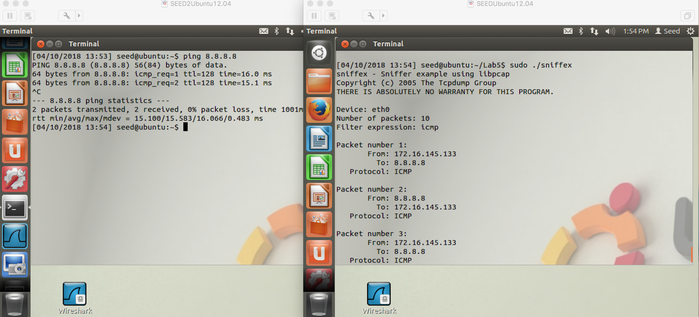  
      Here is a screenshot of the *sniffex* program running while not in promiscuous mode:  
      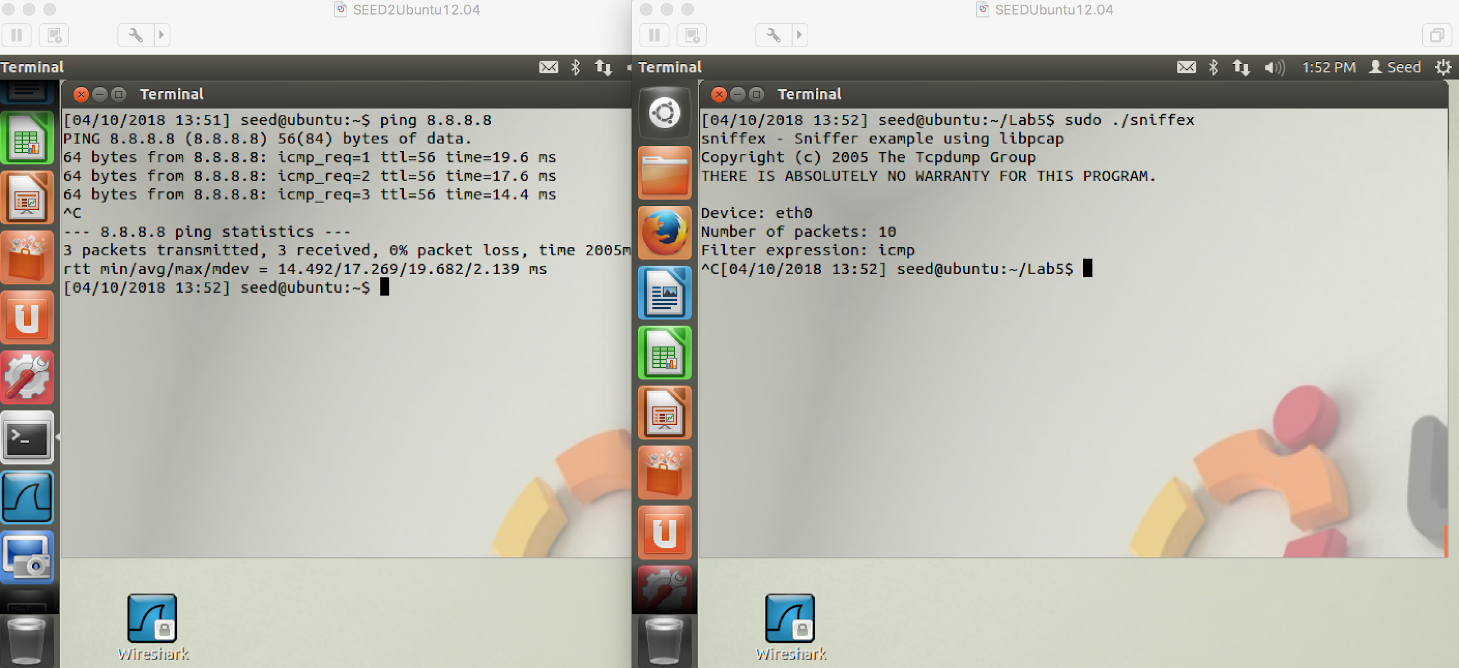  
      When not in promiscuous mode, it doesn’t detect the packets being transmitted by the other VM, whereas it does detect the packets if it is in promiscuous mode.
  + Task 1b:  
    The filter used by the *sniffex* program can be changed by modifying the *char []filter_exp* at line 510 of the *sniffex.c* file.  
    The first filter was built by setting the *char []filter_exp* as follows:  
      
    char filter_exp[] = "icmp and (src host 172.16.145.133 and dst host 8.8.8.8) or (src host 8.8.8.8 and dst host 172.16.145.133)";

Here is a screenshot of the filter only working for ICMP packets to and from those two specific IP addresses:  
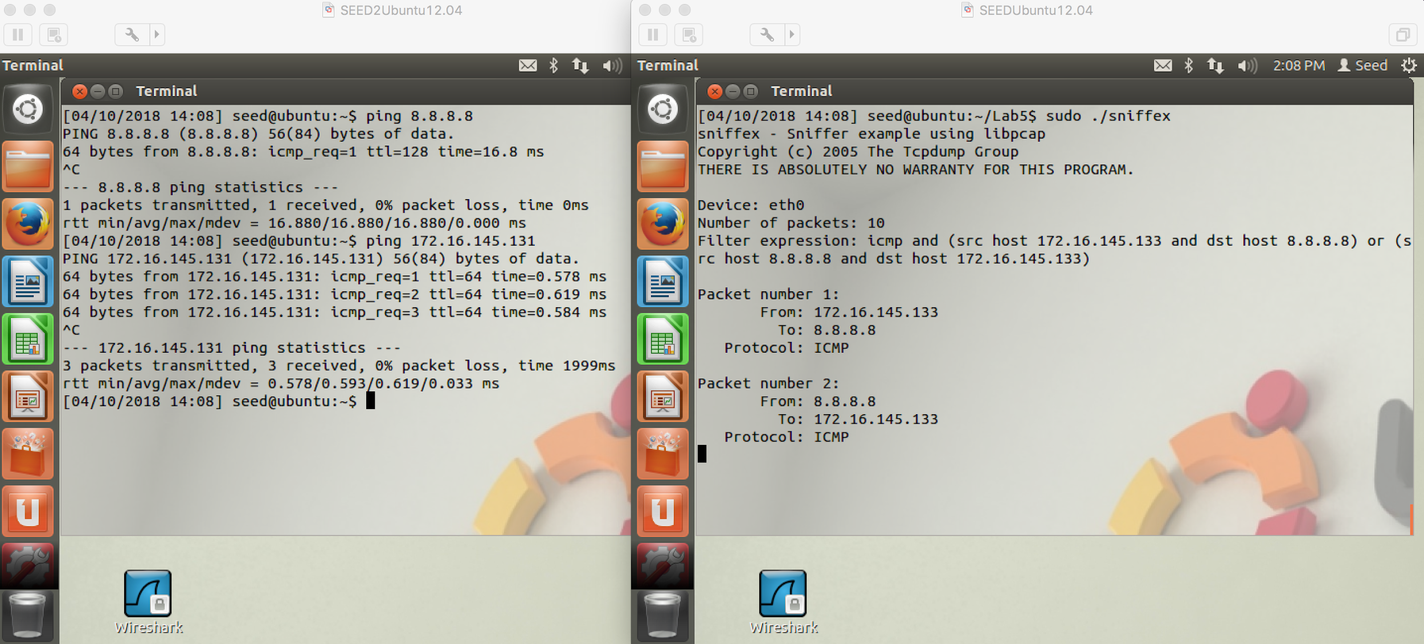  
Notice how only the ping requests between the VM on the left and 8.8.8.8 are logged by the sniffer on the right.  
  
The second filter was built by setting the *char []filter_exp* as follows:  
  
char filter_exp[] = "tcp dst portrange 10-100";

Here is a screenshot of the filter only allowing destination ports between the range of 10-100 to be logged:  
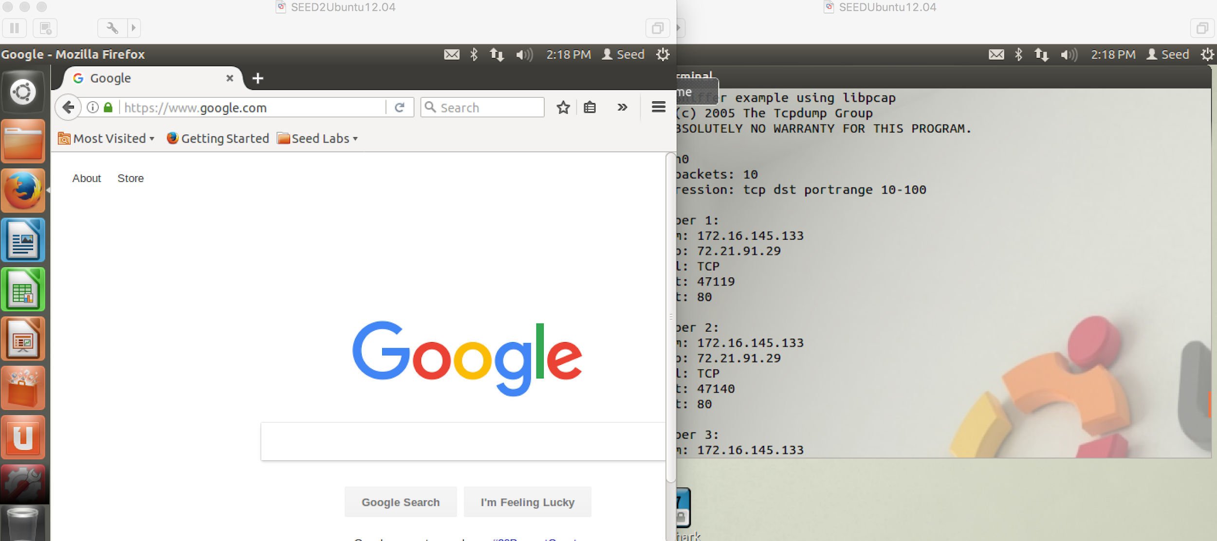  
Notice how it doesn’t capture any of the packets from google, which uses port 443, which is the standard for https, but it does pick up other packets that do have a destination port of 80, indicating that the filter is doing its job correctly.

* + Task 1c:  
    The filter used by *sniffex* must be modified once again in order to successfully pick up on the telnet password. This filter was built by setting the *char []filter_exp* as follows:  
      
    char filter_exp[] = "tcp port 23";  
      
    Here is a screenshot of the *sniffex* program outputting the password for the SEED VM:

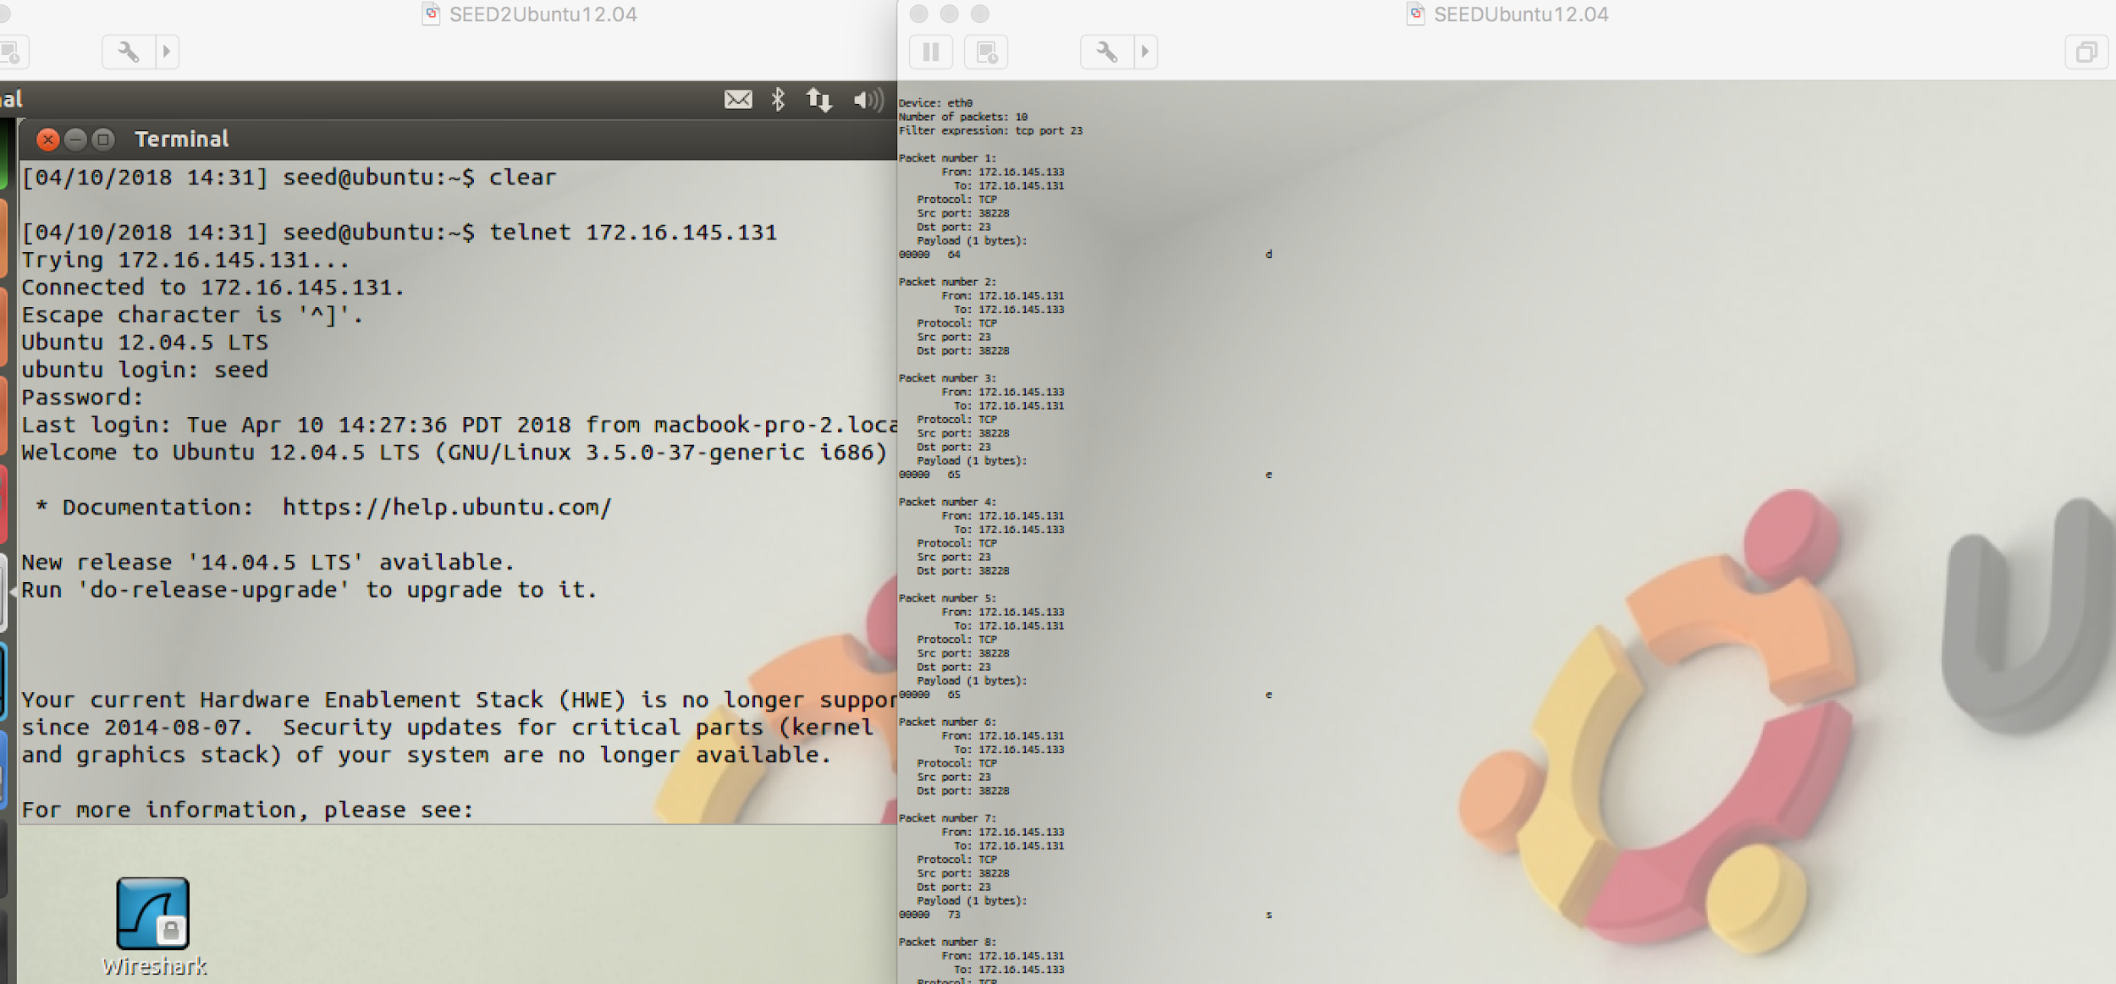

The password was being entered into the telnet client on the left and the sniffer was able to output it on the right. The filter takes advantage of the fact that telnet establishes a connection over port 23.

* Task 2:
  + Task 2a:  
    I downloaded and modified a program, *spoof.c* that successfully spoofs an ICMP request. Here is a screenshot of a wireshark trace when the code is run:

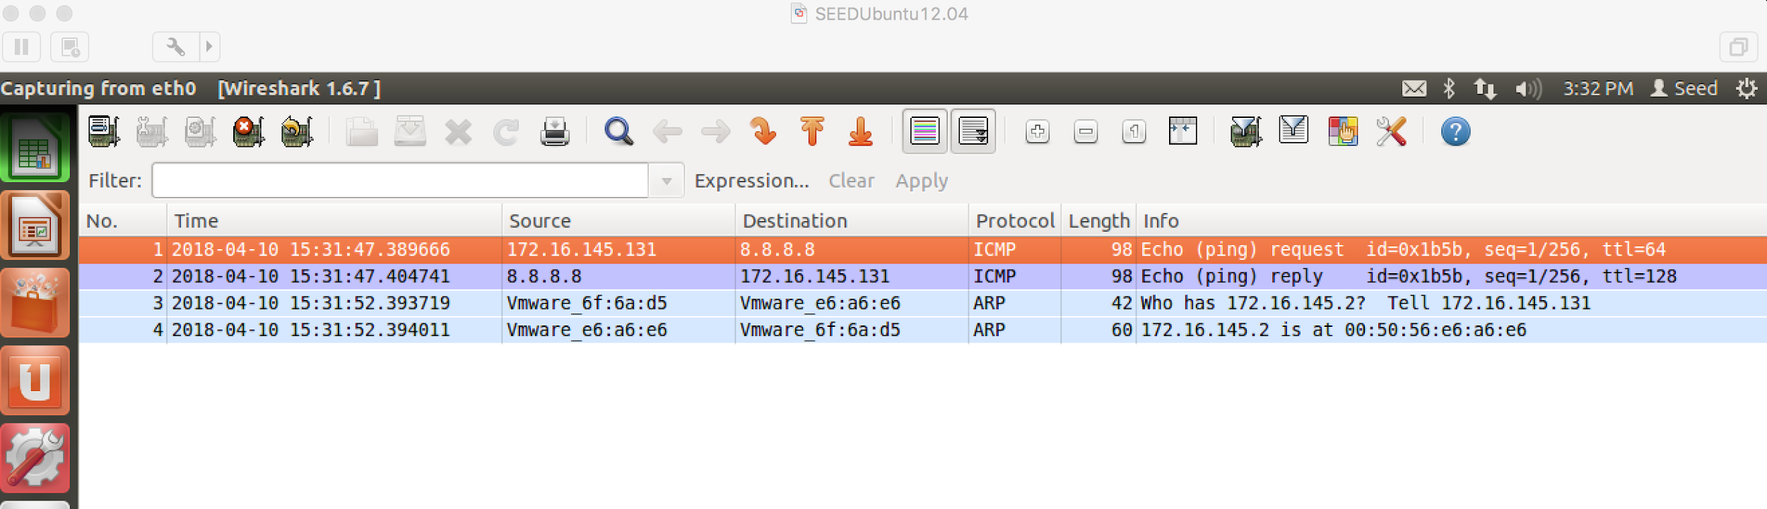  
It successfully pinged the Google public domain 8.8.8.8 and received a reply. The source address was not spoofed in this example, but will be spoofed in Task 2b, demonstrating that it can successfully spoof its source address.  
  
The code listing for *spoof.c* is as follows:  
  
#include <stdio.h>

#include <stdlib.h>

#include <unistd.h>

#include <string.h>

#include <netdb.h>

#include <sys/types.h>

#include <sys/stat.h>

#include <sys/socket.h>

#include <netinet/in_systm.h>

#include <netinet/in.h>

#include <netinet/ip.h>

#include <netinet/udp.h>

#include <netinet/ip_icmp.h>

#include <netinet/tcp.h>

#include <arpa/inet.h>

/*

Internet checksum function (from BSD Tahoe)

We can use this function to calculate checksums for all layers.

ICMP protocol mandates checksum, so we have to calculate it.

*/

unsigned short in_cksum(unsigned short *addr, int len)

{

int nleft = len;

int sum = 0;

unsigned short *w = addr;

unsigned short answer = 0;

while (nleft > 1) {

sum += *w++;

nleft -= 2;

}

if (nleft == 1) {

*(unsigned char *) (&answer) = *(unsigned char *) w;

sum += answer;

}

sum = (sum >> 16) + (sum & 0xFFFF);

sum += (sum >> 16);

answer = ~sum;

return (answer);

}

int main(int argc, char **argv)

{

struct ip ip;

struct udphdr udp;

struct icmp icmp;

int sd;

const int on = 1;

struct sockaddr_in sin;

u_char* packet;

// Grab some space for our packet:

packet = (u_char *)malloc(60);

//IP Layer header construct

/* Fill Layer II (IP protocol) fields...

Header length (including options) in units of 32 bits (4 bytes).

Assuming we will not send any IP options,

IP header length is 20 bytes,

so we need to stuff (20 / 4 = 5 here):

*/

ip.ip_hl = 0x5;

//Protocol Version is 4, meaning Ipv4:

ip.ip_v = 0x4;

//Type of Service. Packet precedence:

ip.ip_tos = 0x0;

/*Total length for our packet require to be converted to the network

byte-order(htons(60), but MAC OS doesn't need this):*/

ip.ip_len = 60;

//ID field uniquely identifies each datagram sent by this host:

ip.ip_id = 0;

/*Fragment offset for our packet.

We set this to 0x0 since we don't desire any fragmentation:*/

ip.ip_off = 0x0;

/*Time to live.

Maximum number of hops that the packet can

pass while travelling through its destination.*/

ip.ip_ttl = 64;

//Upper layer (Layer III) protocol number:

ip.ip_p = IPPROTO_ICMP;

/*We set the checksum value to zero before passing the packet

into the checksum function. Note that this checksum is

calculate over the IP header only. Upper layer protocols

have their own checksum fields, and must be calculated seperately.*/

ip.ip_sum = 0x0;

/*Source IP address, this might well be any IP address that

may or may NOT be one of the assigned address to one of our interfaces:*/

ip.ip_src.s_addr = inet_addr("172.16.145.131");

// Destination IP address:

ip.ip_dst.s_addr = inet_addr("8.8.8.8");

/*We pass the IP header and its length into the internet checksum

function. The function returns us as 16-bit checksum value for

the header:*/

ip.ip_sum = in_cksum((unsigned short *)&ip, sizeof(ip));

//printf("ip cksum: %x\n", ip.ip_sum);

/*We're finished preparing our IP header. Let's copy it into

the very begining of our packet:*/

memcpy(packet, &ip, sizeof(ip));

//ICMP header construct

//As for Layer III (ICMP) data, Icmp type 8 for echo request:

icmp.icmp_type = ICMP_ECHO;

// Code 0. Echo Request.

icmp.icmp_code = 0;

//ID. random number:

icmp.icmp_id = htons(5153);

//Icmp sequence number use htons to transform big endian:

icmp.icmp_seq = htons(0x1);

/*Just like with the Ip header, we set the ICMP header

checksum to zero and pass the icmp packet into the

cheksum function. We store the returned value in the

checksum field of ICMP header:*/

icmp.icmp_cksum = 0;

// printf("chksum: %x\n",in_cksum((unsigned short *)&icmp, sizeof(icmp)));

icmp.icmp_cksum = htons(0x8336);//in_cksum((unsigned short *)&icmp, 8);

//We append the ICMP header to the packet at offset 20:

memcpy(packet + 20, &icmp, 8);

/*We crafted our packet byte-by-byte. It's time we inject

it into the network. First create our raw socket:*/

if ((sd = socket(AF_INET, SOCK_RAW, IPPROTO_RAW)) < 0) {

perror("raw socket");

exit(1);

}

/*We tell kernel that we've also prepared the IP header;

there's nothing that the IP stack will do about it:*/

if (setsockopt(sd, IPPROTO_IP, IP_HDRINCL, &on, sizeof(on)) < 0) {

perror("setsockopt");

exit(1);

}

/*Still, the kernel is going to prepare Layer I data for us.

For that, we need to specify a destination for the kernel in

order for it to decide where to send the raw datagram. We fill

in a struct in_addr with the desired destination IP address,

and pass this structure to the sendto(2) or sendmsg(2) system calls:*/

memset(&sin, 0, sizeof(sin));

sin.sin_family = AF_INET;

sin.sin_addr.s_addr = ip.ip_dst.s_addr;

/*As for writing the packet... We cannot use send(2)

system call for this, since the socket is not a "connected"

type of socket. As stated in the above paragraph, we need

to tell where to send the raw IP datagram. sendto(2) and

sendmsg(2) system calls are designed to handle this:*/

if (sendto(sd, packet, 60, 0, (struct sockaddr *)&sin,

sizeof(struct sockaddr)) < 0) {

perror("sendto");

exit(1);

}

return 0;

}

* + Task 2b:  
    The program, *spoof.c* had to be modified slightly to spoof my second VM’s address. Here is a screenshot of a wireshark trace when the code is run:

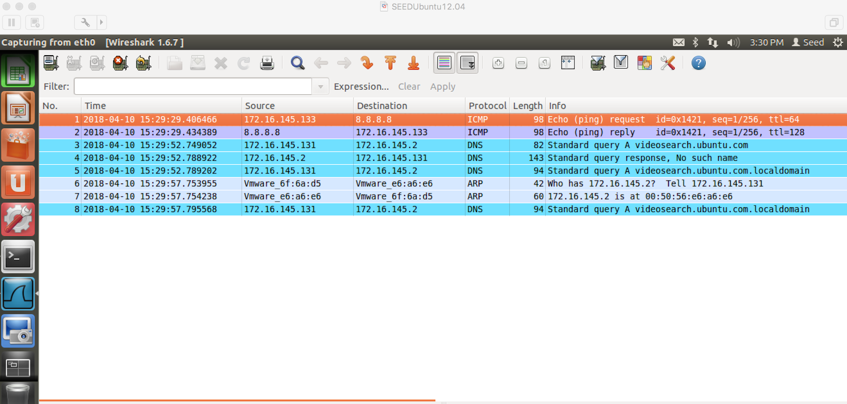

Now the request, which is actually coming from 172.16.145.131, appears to be coming from 172.1.145.133. And 8.8.8.8 responds directly to 172.16.145.133. So the ICMP request is successfully spoofed.

* + Task 2c:  
    Here is a screenshot of the ethernet frame from the source 01:02:03:04:05:06 being spoofed:  
    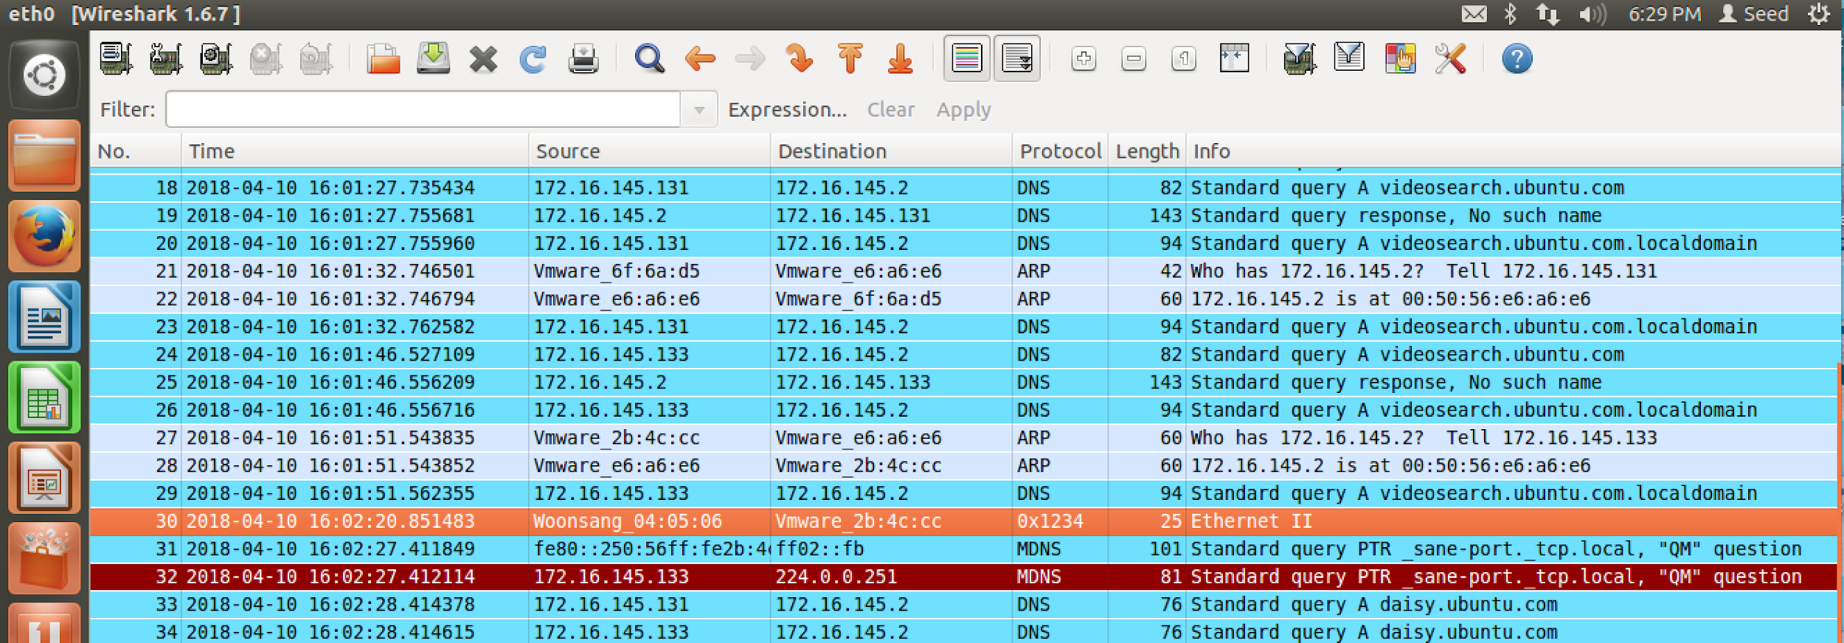  
    Wireshark represents it as Woonsang 04:05:06 for some reason, but if you inspect the packet more with Wireshark it does show up as 01:02:03:04:05:06. I used a modified file that I found online in order to spoof the ethernet frame. The code listing for the c program I used to spoof the ethernet frame is as follows:

#include <stdio.h>

#include <stdlib.h>

#include <string.h>

#include <sys/socket.h> /* Must precede if*.h */

#include <linux/if.h>

#include <linux/if_ether.h>

#include <linux/if_packet.h>

#include <sys/ioctl.h>

union ethframe

{

struct

{

struct ethhdr header;

unsigned char data[ETH_DATA_LEN];

} field;

unsigned char buffer[ETH_FRAME_LEN];

};

int main(int argc, char **argv) {

char *iface = "eth0";

unsigned char dest[ETH_ALEN]

= { 0x00, 0x50, 0x56, 0x2B, 0x4C, 0xCC};

unsigned short proto = 0x1234;

unsigned char *data = "hello world";

unsigned short data_len = strlen(data);

int s;

if ((s = socket(AF_PACKET, SOCK_RAW, htons(proto))) < 0) {

printf("Error: could not open socket\n");

return -1;

}

struct ifreq buffer;

int ifindex;

memset(&buffer, 0x00, sizeof(buffer));

strncpy(buffer.ifr_name, iface, IFNAMSIZ);

if (ioctl(s, SIOCGIFINDEX, &buffer) < 0) {

printf("Error: could not get interface index\n");

close(s);

return -1;

}

ifindex = buffer.ifr_ifindex;

unsigned char source[ETH_ALEN]

= {0x01, 0x02, 0x03, 0x04, 0x05, 0x06};

if (ioctl(s, SIOCGIFHWADDR, &buffer) < 0) {

printf("Error: could not get interface address\n");

close(s);

return -1;

}

/* memcpy((void*)source, (void*)(buffer.ifr_hwaddr.sa_data),

ETH_ALEN); */

union ethframe frame;

memcpy(frame.field.header.h_dest, dest, ETH_ALEN);

memcpy(frame.field.header.h_source, source, ETH_ALEN);

frame.field.header.h_proto = htons(proto);

memcpy(frame.field.data, data, data_len);

unsigned int frame_len = data_len + ETH_HLEN;

struct sockaddr_ll saddrll;

memset((void*)&saddrll, 0, sizeof(saddrll));

saddrll.sll_family = PF_PACKET;

saddrll.sll_ifindex = ifindex;

saddrll.sll_halen = ETH_ALEN;

memcpy((void*)(saddrll.sll_addr), (void*)dest, ETH_ALEN);

if (sendto(s, frame.buffer, frame_len, 0,

(struct sockaddr*)&saddrll, sizeof(saddrll)) > 0)

printf("Success!\n");

else

printf("Error, could not send\n");

close(s);

return 0;

}

* Problem 4:  
  Yes, if the length is longer than the actual packet, then the packet will be padded with 0s to fit the arbitrarily set length. However, the packet length must be smaller than 1500 bytes, or else sendto will return a ‘message too long’ error. But yes, any arbitrary value smaller than 1500 will work.
* Problem 5:  
  You do not have to compute this. If left unset, the OS will set the IP header checksum appropriately.
* Problem 6:  
  Root permissions are required run the programs that use raw sockets because in general, root permissions are required to interface with raw sockets. This is because access to a raw socket grants access to all communications from all other processes and users using that interface. If a spoofing program is run without root privileges, it will fail when trying to create the raw socket it needs in order to spoof packets.
* Task 3:  
  In order to test spoofing a reply, I decided to test using an IP address that I knew would not normally respond. Here is a screenshot of VM A sending ICMP echo requests to the IP address 8.8.8.9, which does not reply back.

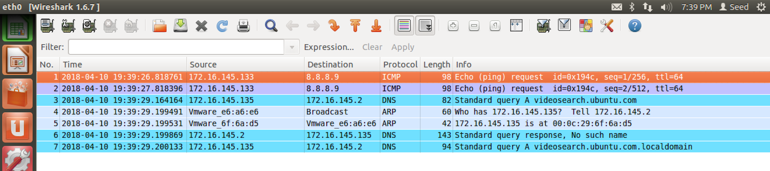

It is apparent that 8.8.8.9 is not nominally responding to ping requests. Now, we will run my sniff-and-spoof program on VM B and see what happens on Wireshark:  
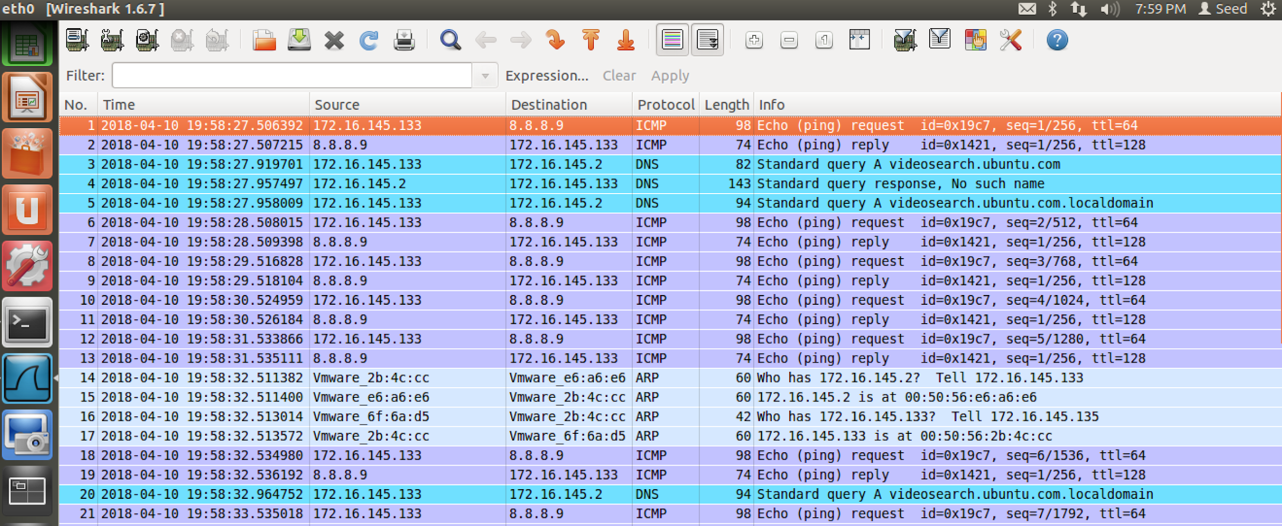  
A reply from 8.8.8.9 is spoofed for each of the ICMP echo requests sent by VM A.

I was able to sniff and spoof by modifying the *sniffex.c* program and the ICMP spoofing program I wrote earlier. Now, my sniffing program executes my spoofing program when an echo request is detected. The code listings will begin on the next page.

*sniffex_spoof.c*

#define APP_NAME "sniffex"

#define APP_DESC "Sniffer example using libpcap"

#define APP_COPYRIGHT "Copyright (c) 2005 The Tcpdump Group"

#define APP_DISCLAIMER "THERE IS ABSOLUTELY NO WARRANTY FOR THIS PROGRAM."

#include <pcap.h>

#include <stdio.h>

#include <string.h>

#include <stdlib.h>

#include <ctype.h>

#include <errno.h>

#include <sys/types.h>

#include <sys/socket.h>

#include <netinet/in.h>

#include <arpa/inet.h>

/* default snap length (maximum bytes per packet to capture) */

#define SNAP_LEN 1518

/* ethernet headers are always exactly 14 bytes [1] */

#define SIZE_ETHERNET 14

/* Ethernet addresses are 6 bytes */

#define ETHER_ADDR_LEN 6

/* Ethernet header */

struct sniff_ethernet {

u_char ether_dhost[ETHER_ADDR_LEN]; /* destination host address */

u_char ether_shost[ETHER_ADDR_LEN]; /* source host address */

u_short ether_type; /* IP? ARP? RARP? etc */

};

/* IP header */

struct sniff_ip {

u_char ip_vhl; /* version << 4 | header length >> 2 */

u_char ip_tos; /* type of service */

u_short ip_len; /* total length */

u_short ip_id; /* identification */

u_short ip_off; /* fragment offset field */

#define IP_RF 0x8000 /* reserved fragment flag */

#define IP_DF 0x4000 /* dont fragment flag */

#define IP_MF 0x2000 /* more fragments flag */

#define IP_OFFMASK 0x1fff /* mask for fragmenting bits */

u_char ip_ttl; /* time to live */

u_char ip_p; /* protocol */

u_short ip_sum; /* checksum */

struct in_addr ip_src,ip_dst; /* source and dest address */

};

#define IP_HL(ip) (((ip)->ip_vhl) & 0x0f)

#define IP_V(ip) (((ip)->ip_vhl) >> 4)

/* TCP header */

typedef u_int tcp_seq;

struct sniff_tcp {

u_short th_sport; /* source port */

u_short th_dport; /* destination port */

tcp_seq th_seq; /* sequence number */

tcp_seq th_ack; /* acknowledgement number */

u_char th_offx2; /* data offset, rsvd */

#define TH_OFF(th) (((th)->th_offx2 & 0xf0) >> 4)

u_char th_flags;

#define TH_FIN 0x01

#define TH_SYN 0x02

#define TH_RST 0x04

#define TH_PUSH 0x08

#define TH_ACK 0x10

#define TH_URG 0x20

#define TH_ECE 0x40

#define TH_CWR 0x80

#define TH_FLAGS (TH_FIN|TH_SYN|TH_RST|TH_ACK|TH_URG|TH_ECE|TH_CWR)

u_short th_win; /* window */

u_short th_sum; /* checksum */

u_short th_urp; /* urgent pointer */

};

void

got_packet(u_char *args, const struct pcap_pkthdr *header, const u_char *packet);

void

print_payload(const u_char *payload, int len);

void

print_hex_ascii_line(const u_char *payload, int len, int offset);

void

print_app_banner(void);

void

print_app_usage(void);

/*

* app name/banner

*/

void

print_app_banner(void)

{

printf("%s - %s\n", APP_NAME, APP_DESC);

printf("%s\n", APP_COPYRIGHT);

printf("%s\n", APP_DISCLAIMER);

printf("\n");

return;

}

/*

* print help text

*/

void

print_app_usage(void)

{

printf("Usage: %s [interface]\n", APP_NAME);

printf("\n");

printf("Options:\n");

printf(" interface Listen on <interface> for packets.\n");

printf("\n");

return;

}

/*

* print data in rows of 16 bytes: offset hex ascii

*

* 00000 47 45 54 20 2f 20 48 54 54 50 2f 31 2e 31 0d 0a GET / HTTP/1.1..

*/

void

print_hex_ascii_line(const u_char *payload, int len, int offset)

{

int i;

int gap;

const u_char *ch;

/* offset */

printf("%05d ", offset);

/* hex */

ch = payload;

for(i = 0; i < len; i++) {

printf("%02x ", *ch);

ch++;

/* print extra space after 8th byte for visual aid */

if (i == 7)

printf(" ");

}

/* print space to handle line less than 8 bytes */

if (len < 8)

printf(" ");

/* fill hex gap with spaces if not full line */

if (len < 16) {

gap = 16 - len;

for (i = 0; i < gap; i++) {

printf(" ");

}

}

printf(" ");

/* ascii (if printable) */

ch = payload;

for(i = 0; i < len; i++) {

if (isprint(*ch))

printf("%c", *ch);

else

printf(".");

ch++;

}

printf("\n");

return;

}

/*

* print packet payload data (avoid printing binary data)

*/

void

print_payload(const u_char *payload, int len)

{

int len_rem = len;

int line_width = 16; /* number of bytes per line */

int line_len;

int offset = 0; /* zero-based offset counter */

const u_char *ch = payload;

if (len <= 0)

return;

/* data fits on one line */

if (len <= line_width) {

print_hex_ascii_line(ch, len, offset);

return;

}

/* data spans multiple lines */

for ( ;; ) {

/* compute current line length */

line_len = line_width % len_rem;

/* print line */

print_hex_ascii_line(ch, line_len, offset);

/* compute total remaining */

len_rem = len_rem - line_len;

/* shift pointer to remaining bytes to print */

ch = ch + line_len;

/* add offset */

offset = offset + line_width;

/* check if we have line width chars or less */

if (len_rem <= line_width) {

/* print last line and get out */

print_hex_ascii_line(ch, len_rem, offset);

break;

}

}

return;

}

/*

* dissect/print packet

*/

void

got_packet(u_char *args, const struct pcap_pkthdr *header, const u_char *packet)

{

static int count = 1; /* packet counter */

/* declare pointers to packet headers */

const struct sniff_ethernet *ethernet; /* The ethernet header [1] */

const struct sniff_ip *ip; /* The IP header */

const struct sniff_tcp *tcp; /* The TCP header */

const char *payload; /* Packet payload */

int size_ip;

int size_tcp;

int size_payload;

printf("\nPacket number %d:\n", count);

count++;

/* define ethernet header */

ethernet = (struct sniff_ethernet*)(packet);

/* define/compute ip header offset */

ip = (struct sniff_ip*)(packet + SIZE_ETHERNET);

size_ip = IP_HL(ip)*4;

if (size_ip < 20) {

printf(" * Invalid IP header length: %u bytes\n", size_ip);

return;

}

/* print source and destination IP addresses */

printf(" From: %s\n", inet_ntoa(ip->ip_src));

printf(" To: %s\n", inet_ntoa(ip->ip_dst));

/* determine protocol */

switch(ip->ip_p) {

case IPPROTO_TCP:

printf(" Protocol: TCP\n");

break;

case IPPROTO_UDP:

printf(" Protocol: UDP\n");

return;

case IPPROTO_ICMP:

printf(" Protocol: ICMP\n");

int pid = fork();

if(pid == 0) {

char *cmd = "./spoof_args";

char *arg1 = strdup(inet_ntoa(ip->ip_dst));

char *arg2 = strdup(inet_ntoa(ip->ip_src));

execlp(cmd, cmd, arg1, arg2, NULL);

}

return;

case IPPROTO_IP:

printf(" Protocol: IP\n");

return;

default:

printf(" Protocol: unknown\n");

return;

}

/*

* OK, this packet is TCP.

*/

/* define/compute tcp header offset */

tcp = (struct sniff_tcp*)(packet + SIZE_ETHERNET + size_ip);

size_tcp = TH_OFF(tcp)*4;

if (size_tcp < 20) {

printf(" * Invalid TCP header length: %u bytes\n", size_tcp);

return;

}

printf(" Src port: %d\n", ntohs(tcp->th_sport));

printf(" Dst port: %d\n", ntohs(tcp->th_dport));

/* define/compute tcp payload (segment) offset */

payload = (u_char *)(packet + SIZE_ETHERNET + size_ip + size_tcp);

/* compute tcp payload (segment) size */

size_payload = ntohs(ip->ip_len) - (size_ip + size_tcp);

/*

* Print payload data; it might be binary, so don't just

* treat it as a string.

*/

if (size_payload > 0) {

printf(" Payload (%d bytes):\n", size_payload);

print_payload(payload, size_payload);

}

return;

}

int main(int argc, char **argv)

{

char *dev = NULL; /* capture device name */

char errbuf[PCAP_ERRBUF_SIZE]; /* error buffer */

pcap_t *handle; /* packet capture handle */

char filter_exp[] = "icmp[icmptype] == icmp-echo";

struct bpf_program fp; /* compiled filter program (expression) */

bpf_u_int32 mask; /* subnet mask */

bpf_u_int32 net; /* ip */

int num_packets = 10; /* number of packets to capture */

print_app_banner();

/* check for capture device name on command-line */

if (argc == 2) {

dev = argv[1];

}

else if (argc > 2) {

fprintf(stderr, "error: unrecognized command-line options\n\n");

print_app_usage();

exit(EXIT_FAILURE);

}

else {

/* find a capture device if not specified on command-line */

dev = pcap_lookupdev(errbuf);

if (dev == NULL) {

fprintf(stderr, "Couldn't find default device: %s\n",

errbuf);

exit(EXIT_FAILURE);

}

}

/* get network number and mask associated with capture device */

if (pcap_lookupnet(dev, &net, &mask, errbuf) == -1) {

fprintf(stderr, "Couldn't get netmask for device %s: %s\n",

dev, errbuf);

net = 0;

mask = 0;

}

/* print capture info */

printf("Device: %s\n", dev);

printf("Number of packets: %d\n", num_packets);

printf("Filter expression: %s\n", filter_exp);

/* open capture device */

handle = pcap_open_live(dev, SNAP_LEN, 1, 1000, errbuf);

if (handle == NULL) {

fprintf(stderr, "Couldn't open device %s: %s\n", dev, errbuf);

exit(EXIT_FAILURE);

}

/* make sure we're capturing on an Ethernet device [2] */

if (pcap_datalink(handle) != DLT_EN10MB) {

fprintf(stderr, "%s is not an Ethernet\n", dev);

exit(EXIT_FAILURE);

}

/* compile the filter expression */

if (pcap_compile(handle, &fp, filter_exp, 0, net) == -1) {

fprintf(stderr, "Couldn't parse filter %s: %s\n",

filter_exp, pcap_geterr(handle));

exit(EXIT_FAILURE);

}

/* apply the compiled filter */

if (pcap_setfilter(handle, &fp) == -1) {

fprintf(stderr, "Couldn't install filter %s: %s\n",

filter_exp, pcap_geterr(handle));

exit(EXIT_FAILURE);

}

/* now we can set our callback function */

pcap_loop(handle, num_packets, got_packet, NULL);

/* cleanup */

pcap_freecode(&fp);

pcap_close(handle);

printf("\nCapture complete.\n");

return 0;

}

As you can see, when an ICMP echo request is detect, useful information is then passed to *spoof_args*, which uses the information sniffed from the ICMP echo request to generate a spoofed ICMP echo response. The code listing for *spoof_args.c* will be on the next page.

*spoof_args.c*

#include <stdio.h>

#include <stdlib.h>

#include <unistd.h>

#include <string.h>

#include <netdb.h>

#include <sys/types.h>

#include <sys/stat.h>

#include <sys/socket.h>

#include <netinet/in_systm.h>

#include <netinet/in.h>

#include <netinet/ip.h>

#include <netinet/udp.h>

#include <netinet/ip_icmp.h>

#include <netinet/tcp.h>

#include <arpa/inet.h>

/*

Internet checksum function (from BSD Tahoe)

We can use this function to calculate checksums for all layers.

ICMP protocol mandates checksum, so we have to calculate it.

*/

unsigned short in_cksum(unsigned short *addr, int len)

{

int nleft = len;

int sum = 0;

unsigned short *w = addr;

unsigned short answer = 0;

while (nleft > 1) {

sum += *w++;

nleft -= 2;

}

if (nleft == 1) {

*(unsigned char *) (&answer) = *(unsigned char *) w;

sum += answer;

}

sum = (sum >> 16) + (sum & 0xFFFF);

sum += (sum >> 16);

answer = ~sum;

return (answer);

}

int main(int argc, char **argv)

{

struct ip ip;

struct udphdr udp;

struct icmp icmp;

int sd;

const int on = 1;

struct sockaddr_in sin;

u_char* packet;

// Grab some space for our packet:

packet = (u_char *)malloc(60);

//IP Layer header construct

/* Fill Layer II (IP protocol) fields...

Header length (including options) in units of 32 bits (4 bytes).

Assuming we will not send any IP options,

IP header length is 20 bytes,

so we need to stuff (20 / 4 = 5 here):

*/

ip.ip_hl = 0x5;

//Protocol Version is 4, meaning Ipv4:

ip.ip_v = 0x4;

//Type of Service. Packet precedence:

ip.ip_tos = 0x0;

/*Total length for our packet require to be converted to the network

byte-order(htons(60), but MAC OS doesn't need this):*/

ip.ip_len = 60;

//ID field uniquely identifies each datagram sent by this host:

ip.ip_id = 0;

/*Fragment offset for our packet.

We set this to 0x0 since we don't desire any fragmentation:*/

ip.ip_off = 0x0;

/*Time to live.

Maximum number of hops that the packet can

pass while travelling through its destination.*/

ip.ip_ttl = 128;

//Upper layer (Layer III) protocol number:

ip.ip_p = IPPROTO_ICMP;

/*We set the checksum value to zero before passing the packet

into the checksum function. Note that this checksum is

calculate over the IP header only. Upper layer protocols

have their own checksum fields, and must be calculated seperately.*/

ip.ip_sum = 0x0;

/*Source IP address, this might well be any IP address that

may or may NOT be one of the assigned address to one of our interfaces:*/

ip.ip_src.s_addr = inet_addr(argv[1]);

// Destination IP address:

ip.ip_dst.s_addr = inet_addr(argv[2]);

/*We pass the IP header and its length into the internet checksum

function. The function returns us as 16-bit checksum value for

the header:*/

ip.ip_sum = in_cksum((unsigned short *)&ip, sizeof(ip));

//printf("ip cksum: %x\n", ip.ip_sum);

/*We're finished preparing our IP header. Let's copy it into

the very begining of our packet:*/

memcpy(packet, &ip, sizeof(ip));

//ICMP header construct

//As for Layer III (ICMP) data, Icmp type 8 for echo request:

// icmp.icmp_type = ICMP_ECHO;

//As for Layer III (ICMP) data, Icmp type 8 for echo reply:

icmp.icmp_type = ICMP_ECHOREPLY;

// Code 8. Echo Request.

// Code 0. Echo Reply.

icmp.icmp_code = 0;

//ID. random number:

//icmp.icmp_id = htons(5153);

//Icmp sequence number use htons to transform big endian:

icmp.icmp_seq = htons(0x1);

/*Just like with the Ip header, we set the ICMP header

checksum to zero and pass the icmp packet into the

cheksum function. We store the returned value in the

checksum field of ICMP header:*/

icmp.icmp_cksum = 0;

// printf("chksum: %x\n",in_cksum((unsigned short *)&icmp, sizeof(icmp)));

icmp.icmp_cksum = htons(0x8336);//in_cksum((unsigned short *)&icmp, 8);

//We append the ICMP header to the packet at offset 20:

memcpy(packet + 20, &icmp, 8);

/*We crafted our packet byte-by-byte. It's time we inject

it into the network. First create our raw socket:*/

if ((sd = socket(AF_INET, SOCK_RAW, IPPROTO_RAW)) < 0) {

perror("raw socket");

exit(1);

}

/*We tell kernel that we've also prepared the IP header;

there's nothing that the IP stack will do about it:*/

if (setsockopt(sd, IPPROTO_IP, IP_HDRINCL, &on, sizeof(on)) < 0) {

perror("setsockopt");

exit(1);

}

/*Still, the kernel is going to prepare Layer I data for us.

For that, we need to specify a destination for the kernel in

order for it to decide where to send the raw datagram. We fill

in a struct in_addr with the desired destination IP address,

and pass this structure to the sendto(2) or sendmsg(2) system calls:*/

memset(&sin, 0, sizeof(sin));

sin.sin_family = AF_INET;

sin.sin_addr.s_addr = ip.ip_dst.s_addr;

/*As for writing the packet... We cannot use send(2)

system call for this, since the socket is not a "connected"

type of socket. As stated in the above paragraph, we need

to tell where to send the raw IP datagram. sendto(2) and

sendmsg(2) system calls are designed to handle this:*/

if (sendto(sd, packet, 60, 0, (struct sockaddr *)&sin,

sizeof(struct sockaddr)) < 0) {

perror("sendto");

exit(1);

}

return 0;

}